# **AERO CLUB MNNIT**

# **AVISHKAR 2K20**

# **DRONE AUTOMATION (GUARDIAN)**

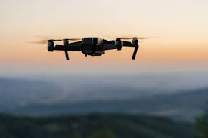 

# **Round: 2**

**Task: 1 (horizontal 8 figures and with the drone swarm)**

* Connecting 2 Drones to Mission Planner.

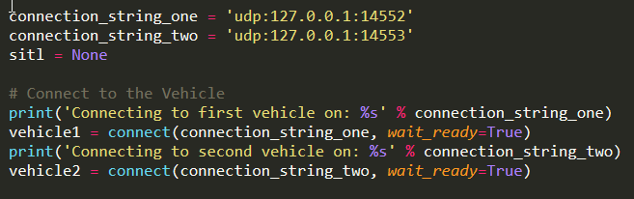

* Defining Indivisual Points for different drone (Four cicles in different Quadrents).

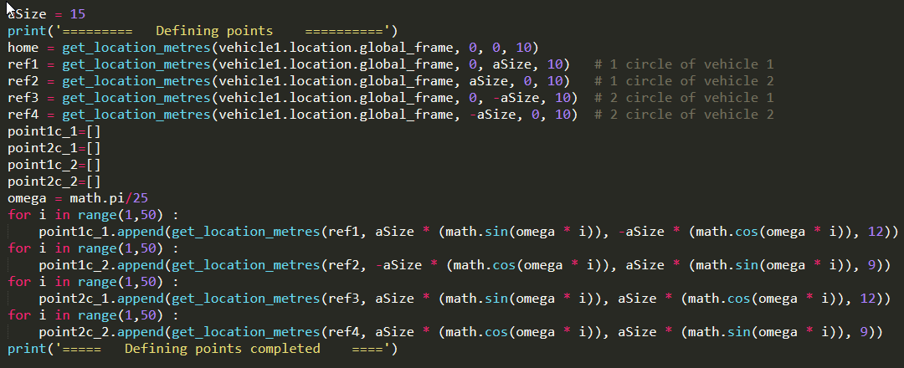

* Main Function (following 2 Trajectories Simultaneously)

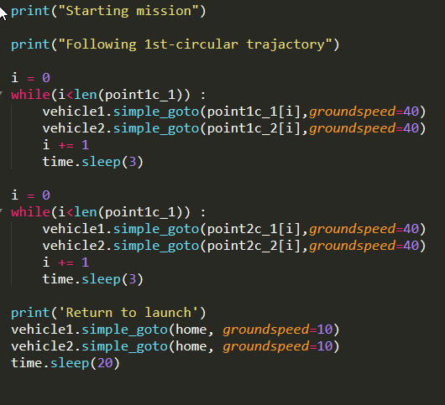

**Task: 2 (2 Circles – one about Vertical Axis another Horizontal Axis)**

* Defining Points(2-Circular Trajectories)

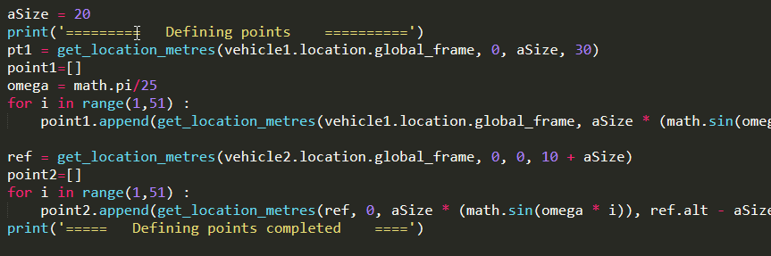

* Main Function (Moving to the defined points)

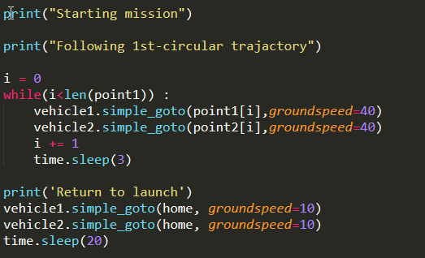

**Task: 3 (Different Shapes By 2 Drones by giving instruction to just one Leader Drone)**

* Triangle (Defining Points for Leader Drone)

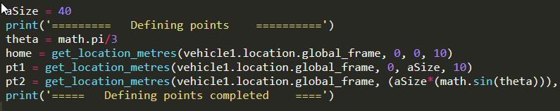

* Triangle (Main Function)

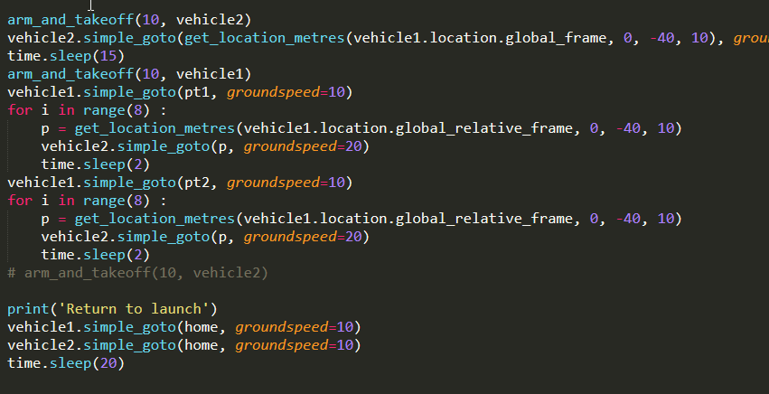

* Line (Defining Points for Leader Drone)

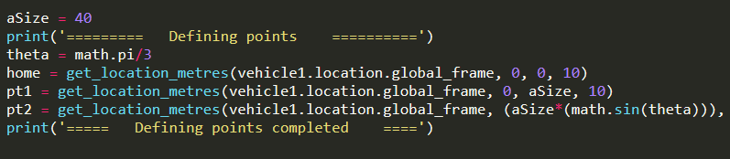

* Line (Main Function)

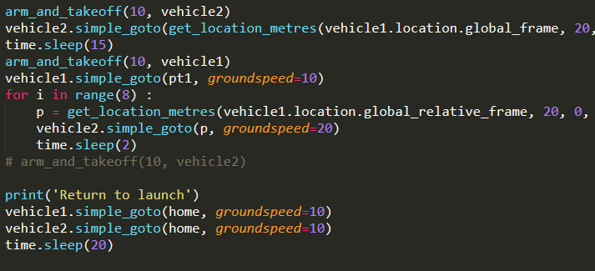

* L-Shape (Defining Points for Leader Drone)

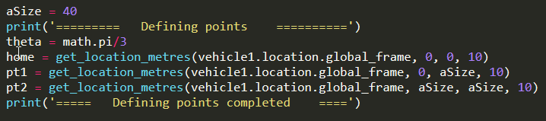

* L-Shape (Main Function)

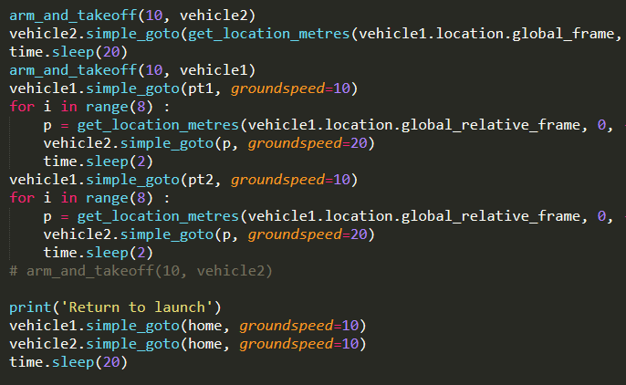

**Task: BONUS (Task 2 in Airsim)**

* Connecting multiple drones in Airsim

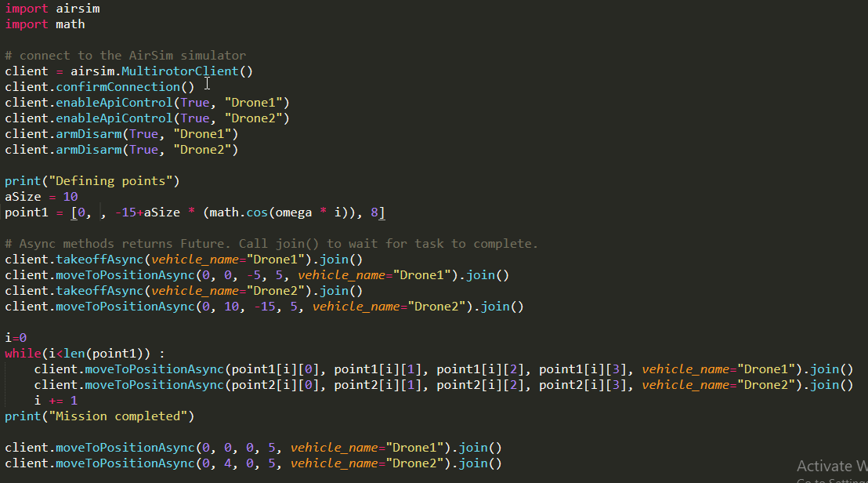

* Defining Points and Execution Main Function

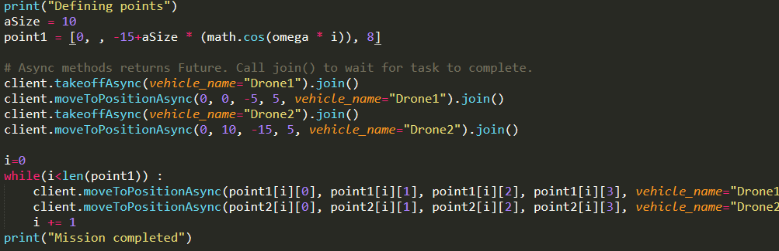

THANK YOU

========================================================

Team Name : K33P_Qu!34

Member 1: Amit Gupta

Member 2: Karimulla Mohd.

GitHub: https://github.com/AmitGupta7580/Drone_Automation

Links of YouTube Videos:

(Task 1) - <https://youtu.be/rmQG_iYOPys>

(Task 2) - <https://youtu.be/EHKCY1x9GSI>

(Task 3) - <https://youtu.be/vaTLAdxjci0>

<https://youtu.be/MnpPyvZmcWU>

<https://youtu.be/UV9NsKFdPzs>

(BOUNUS TASK) –

(AirSim) : <https://youtu.be/ECzPRfspGp4>

Sorry for that :

Issues With Vedio Recording :

* I am using In built Screen Recode (XBOX) which record screen of one application at one time so , I am not able to show executing the python script
* As I am using Mobile data so, I upload the video in 2x speed.